Job Description
Job Title | Early Years Worker, Children and Families Project at The Place
Salary Range/Grade | SP 5-7
Job Location | The Place, Corn Exchange Gloucester Street, Faringdon SN7 7JA
Hours Per Week | 11.5 term-time only
Reports To | Co-ordinator, The Place
What positive impact will this position have on children, young people and families?
This role is part of a committed team of staff and volunteers at The Place who provide
groups, activities and signposting for local families in Faringdon with children under 5.
Families come to find support from the team and each other, make friends, learn together
and have fun.
General Description and Tasks
- Plan and deliver a variety of early years groups and sessions which enable positive outcomes for early years children, their parents and the family as a whole.

- Promote positive play, communication and learning in line with the Early Years Foundation Stage (EYFS) framework and principles.

- Support parents/carers in how they play with their children to encourage attachment, good child development and positive relationships.
- Promote the welfare and well-being of early years children, following through on any safeguarding concerns in line with relevant policies and processes.
- Ensure the environment is welcoming and safe to support families; that equipment and resources are safe, clean and fit for purpose.
- To work together with other partners or organisations involved in delivering early years or family services.
- Always demonstrate Spurgeons Values & Behaviours in your role and interactions.

 | Person Specification | Essential/  Desirable
Qualification(s) | - NVQ level 3 qualification in Child Care, or experience of working with young children and NVQ level 3 in community-based practice or be working towards NVQ level 3 in Child Care  - General education to GCSE standard preferably including Maths and English Language grade C and above  - Evidence of recent and continuing professional development in relation to child development and early years practice. | E  E  D
Experience | - Working with early years children and their families  - Setting up for and supervising play sessions  - Working effectively as part of a team, which includes volunteers  - Maintaining registers, collating and monitoring information  - Working within confidential and data protection boundaries | E  E  E  E  E
Skills | - Excellent interpersonal and communication skills applicable across a wide range of people and ages, to build positive relationships with children and their parents/carers  - Able to work calmly and efficiently in a busy setting  - Responsive and flexible to the needs of the service  - Able to use initiative, follow protocols and provide direction  - Proficient IT skills in Microsoft Word and Excel | E  E  E  E  E
Knowledge | - A working knowledge and demonstrable understanding of child protection and safeguarding issues, including Safeguarding and Child Protection policies, procedures and systems  - An understanding of the Early Years Foundation Stage  - Awareness of Health & Safety practice in a play environment  - A broad knowledge and understanding of Equity, Diversity and Inclusion so as to promote equality and inclusion within sessions and activities, including support for children with additional needs | E  E  E  E
Additional Requirements | - Flexible approach to hours to support the needs of the project, including some weekend and evening work  - Occasional outreach work in Faringdon | E  D
Personal Qualities | - Empathetic  - Organised  - Compassionate  - Approachable  - Flexible  - Collaborative  - Diplomatic  - Resourceful  - Quality driven  - Self motivated

What We Expect From You

Our Values
Everything we do is driven by our values which define who we are and how we work together to support children, young people and families.

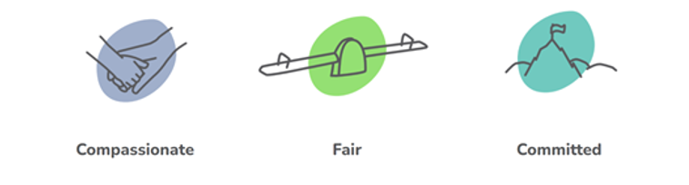
Our Behaviours
We have certain expectations of your interactions with our colleagues, our partners, children and the general public. We would expect you to demonstrate these behaviours as an employee of Spurgeons.
- Put children and young people first in everything we do
- Respect and value every individual
- Listen to understand without judging
- Be open and honest with kindness
- Persevere to be our absolute best and do what we say we will do
- Bring out the best in each other as we work together for the right result

Safer Recruitment & Employment Policy
As part of Spurgeons Safer Recruitment & Employment Policy, any appointment to this role will be subject to the completion of a DBS application and obtaining satisfactory references.

Equal Opportunities For All
We actively encourage applications from a broad and deep range of backgrounds and experiences. We are a Disability Confident Employer.

